**What is a SAP Client?**

**Client** is a 'Customer'. in SAP. We can say that each customer maps to one client. Within one SAP instance, a number of Clients can be created. No need to install separate softwares for each and every customer.It provides isolation ,one client cannot see the data of another client.

[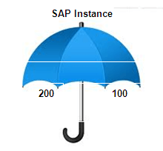](https://www.guru99.com/images/sap/2013/02/022613_0657_Introductio1.png)

As depicted above 100 and 200 clients exist under one roof. We can create a number of clients in SAP Application (from 000 to 999)

**What does client contain?**

1. **Application Data-**Application data is the data that are stored in the database tables.
2. **Customizing Data -**Customizing data is data created by customers when they customize their systems
3. **User Master Record-**A user master record defines the authorizations assigned to a user. Basis consultants are responsible for maintaining the user master record and assigning authorizations.

**Advantages of Client concept: -**

1. Clients enable SAP SAS providers to install a small number of SAP Systems, but still cater to a large number of customers.
2. Costs are not only saved by sharing hardware and software but multiple customers also use the same application solution, including administration and support.
3. Clients help establish your SAP landscape. For instance, you can have a client for the development team, a client for a test team and a production client.

**SAP comes with three "standard clients": -**

1. 000
2. 001
3. 066

**000 Client: -** We can find this clients in the system as soon as we install SAP r/3 software. This is called master client. Client 000 contains a simple organizational structure of a test company and includes parameters for all applications, standard settings, and configurations for the control of standard transactions and examples to be used in many different profiles of the business applications. It contains client independent data.  
  
**001 Client: -** This clients is a copy of the 000 client including the test company. This client's settings are client-independent if it is configured or customized. People normally use 001 clients to create a new client.  
  
**066 Client: -** This client is called early watch client. The SAP earlywatch alert is a diagnosis service, for solution monitoring of SAP and non-SAP systems in the SAP Solution Manager. Alert may contain Performance issue, average response time, current system load, Database administration,etc..

**How to create a new client?**

Theoretically, we can create clients from 000 to 999.But maintenance of such a large number of clients becomes a challenge.  
**Step 1)**Execute T-Code SCC4

[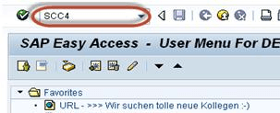](https://www.guru99.com/images/sap/2013/02/022613_0657_Introductio2.png)

**Step 2**) It will bring you to the initial screen of SAP clients.

[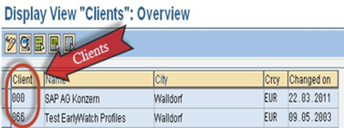](https://www.guru99.com/images/sap/2013/02/022613_0657_Introductio3.png)

Click New Entry to make a new SAP Client

[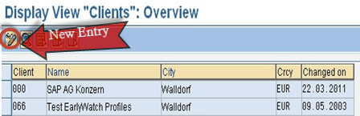](https://www.guru99.com/images/sap/2013/02/022613_0657_Introductio5.png)

**Step 3)**

1. Enter basic details as given below.

* Client number & description
* City to which client Belongs (etc, NY-New York)
* Logical system may be <SID>CLNT<Client Number>
* Std Currency may be (etc EUR)
* Client roles may be Customizing, Demo, Training/Education, Production, etc..

1. Enter your client specific data and set permission for the clients as per your requirement
2. Save
3. Press F3 to come back to **SCC4**

[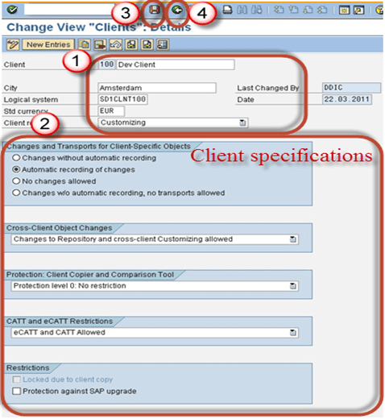](https://www.guru99.com/images/sap/2013/02/022613_0657_Introductio6.png)

**Step 4)**New client will be there in the list.Here we have created client 100.

[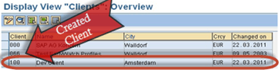](https://www.guru99.com/images/sap/2013/02/022613_0657_Introductio7.png)